LINK Confirmations
Receipt Point Operators:
- Can set up to auto-confirm at the Receipt Point using the Confirmation Customization screen.
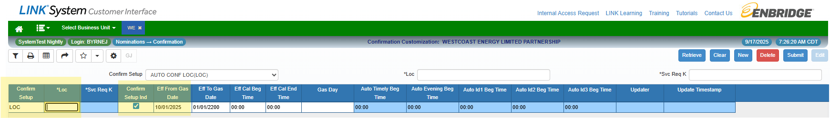
- To add an auto-confirmation at a Location: Retrieve Edit New
  - Confirm Setup = LOC
  - Loc = Receipt Point ID (this is a look-up field)
  - Ensure Confirm Setup Ind is checked
  - Eff From Gas Date = October 1, 2025
  - Eff To Gas Date = Defaults to 01/01/2200; it can be left here unless it needs to be changed.

Delivery Point Operators:
- Timely confirmations are entered in the Request for Confirmation/Confirmation Response screen.
- Enter the Location you are confirming.
- Adjust any quantities as required.
- Select rows and click on the Confirm button.
- If no quantity reductions have been made, nominations will be auto-confirmed at requested quantities on the Timely job run at 12:35pm MT; this is the only job that auto-confirms nominated quantities.
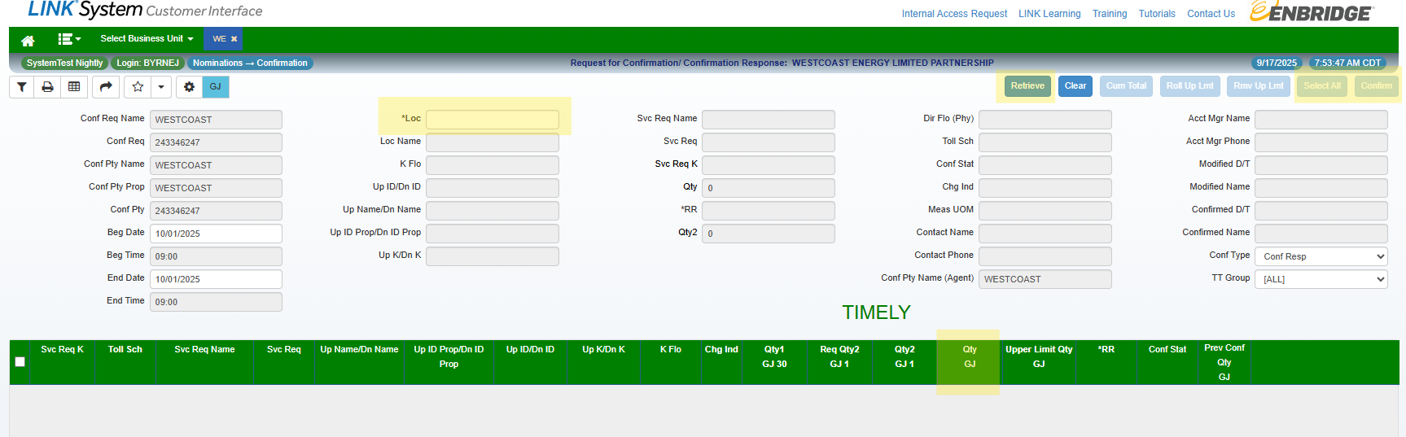
- The Operator will use the Request for Confirmation screen at any time if they need to change confirmed quantities throughout the gas day.
- If a Shipper changes their nomination quantity after Timely, Operator will need to confirm the new nomination quantity in the Intraday Summary Confirmation screen.
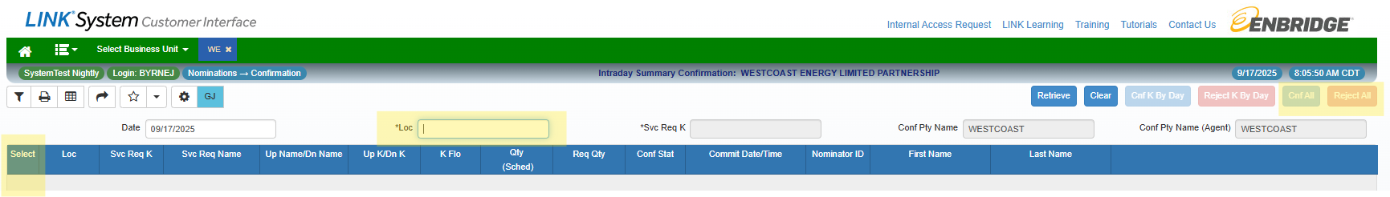
- Select the appropriate rows by clicking in the Select column and then click Cnf All or Reject All as required. Reject requests will remain as previously scheduled.

Pipeline Interconnects:
- If EDI is used, CR’s will be automatically sent from Westcoast.
- EDI results can still be viewed in the Request for Confirmation screen.
- If EDI is not used, confirmations must be done manually through the Request for Confirmation screen and Intraday Confirmation Summary.

Trading Pool Confirmations:
- The Downstream party must Confirm each nomination TO a Trading Pool.
- The Upstream party must Confirm each nomination FROM a Trading Pool.
- Where the confirming party is ALSO the nominating party, the nomination is auto-confirmed.
- Shippers must establish who the nominating party and who the confirming party is for Trading Pool transactions to avoid duplicate nom’s. This is especially important since nominations are auto-confirmed at the Timely job run (12:35pm MT).
- Confirming a TAB nomination is done from the TABS Confirmation Response screen; this is only required if the nomination quantity has changed from Timely submission.
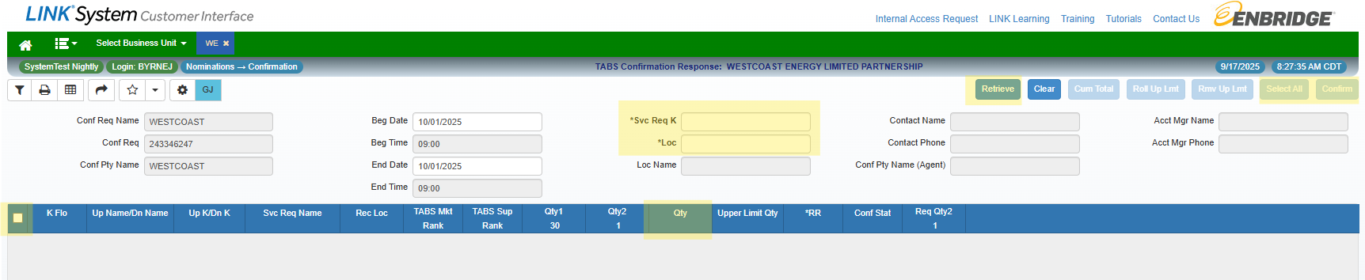
- To confirm nominated quantities, enter your TAB contract in Svc Req K and the Location (WA202 f/ Station 2 Trading Pool or WA209 f/ Huntingdon Trading Pool) and click on Retrieve.
- If required, adjust Qty to the amount you are confirming, then select the lines to confirm be clicking in the box to the left (or Select All) and click Confirm.
- Note: Qty 1 shows the scheduled quantity for the previous Gas Day, and Qty2 shows the last scheduled quantity for the current Gas Day.

Confirmation Email Notifications
Customer Activities Email Notices Available Email Notifications
For Confirming Parties:
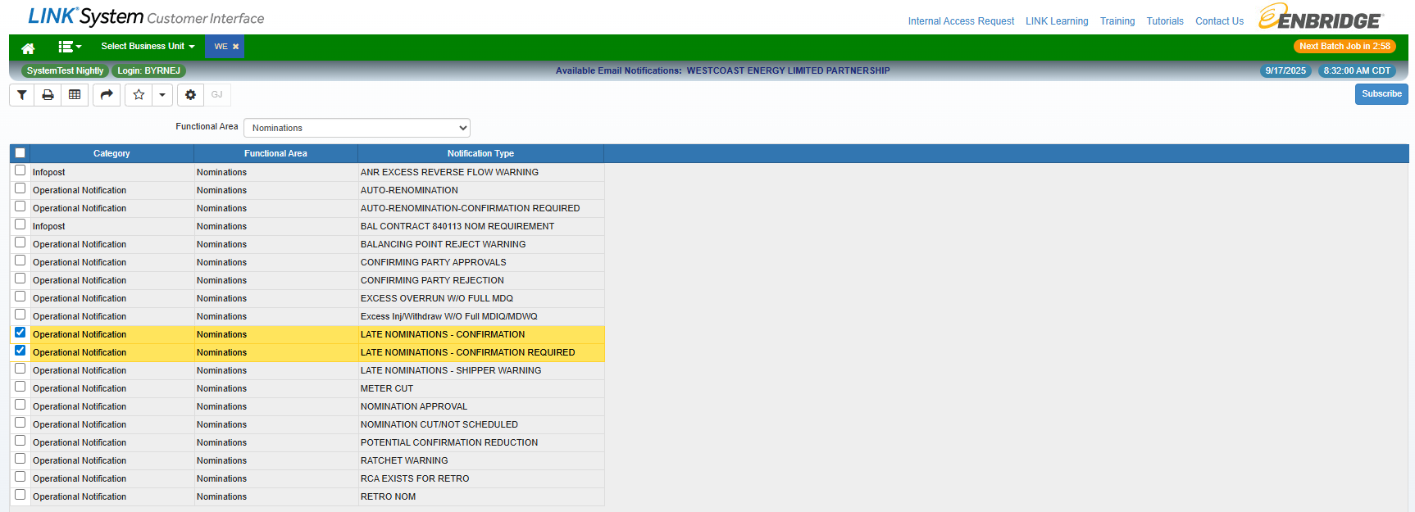
For Nominating Parties:
